**Results Screenshots**

**Bag of Words:**

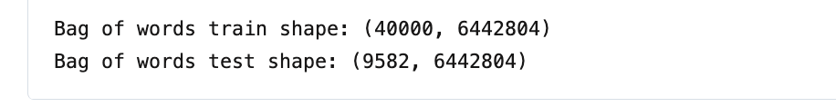

**Term Frequency-Inverse Document Frequency (TF-IDF):**

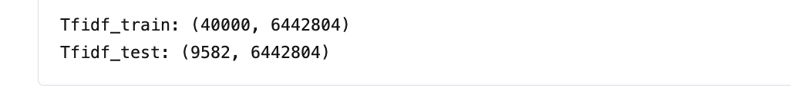

**Train – Test Split:**

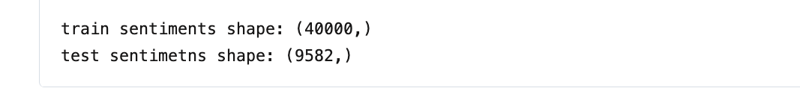

**word cloud for positive review words:**

**word cloud for negative review words:**

**Scaling the Multinomial Naïve Bayes**

**Classification report of BoW model:**

**Classification report of TF-IDF model:**

**Confusion matrix for BoW:**

**Confusion matrix for TF-IDF:**

**Scaling Stochastic Gradient Descent**

**Classification report of BoW model:**

**Classification report of TF-IDF model:**

**Confusion matrix for BoW:**

**Confusion matrix for TF-IDF:**

